

EEEE 536.60L1 and EEEE 636.60L1 –Biorobotics/Cybernetics Lab 2: Data Acquisition and Analysis of EEG Signals using Unicorn Suite

Objective:

The goal of this lab experiment is to introduce the student to biopotential and how they can be recorded using the EEG unicorn band. This experiment includes data collection and analysis of electromyograms EEG. Students are expected to learn how to use unicorn suite software to collect data.

Learning Outcomes:
By completing this lab, students will:
- Develop proficiency in using Python for data analysis and collection.
- Learn to install different packages for unicorn EEG band
- Use unicorn suite band to record EEG signals.

Pre-Requisites:
- Install unicorn suite software from https://github.com/unicorn-bi/Unicorn-Suite- Hybrid-Black .

Background:

The electroencephalogram or EEG is a recording of the biopotentials in the cerebrum of the brain. These potentials are typical recorded at the surface of the scalp and can vary with respect to the emotional, mental, and physiological state of a person. The action potentials and synaptic potentials of an individual neurons are too small to be measured by electrodes. Therefore, an EEG is a measurement of the summation of the electrical signals produce by neurons in a defined area and over a specific amount of time. It is important to note that these neurons need not synchronized but may be producing signals in an asynchronous

manner. EEG signals can be categorized by the four major frequency ranges or brainwaves in which they occur: alpha, beta, delta and theta. The corresponding frequencies, amplitudes, and typical human functionality of the waves are seen in Table 1.

Table 1. Typical frequencies amplitudes and brain functionality of different brain waves.

Brainwave | Frequency Ranges (Hz) | Amplitude (µV) | Human Function
α | 8 - 13 | 2 - 100 | Awake, Quiet, resting, eyes open.
β | 13 - 22 | 5 - 10 | Mental activity or external  stimulus.
δ | 0.5 - 4 | 20 - 100 | -
θ | 4 - 8 | 10 | Emotional stress

A special system of electrode placement called the 10-20 system is used during EEG recordings. The 10 and 20 refer to percent distances of the electrodes from each other with respect to the size of the patient’s head. The letters F, T, C, P, and O in the 10 20 system refer to frontal, temporal, central, parietal, and occipital or essential lobes of the brain excluding central. Also even numbers are located on the right hemisphere and odd numbers on the left hemisphere. The letter z is an indicator of the central line of the head. Figures 2 is a diagram of the 10-20 electrode placement system. When recording EEG signals there is an abundance of noise sources and artifacts. The most predominate artifact in EEG signals are eye blinks. Other sources include activity from muscles in the face and also eye movements.
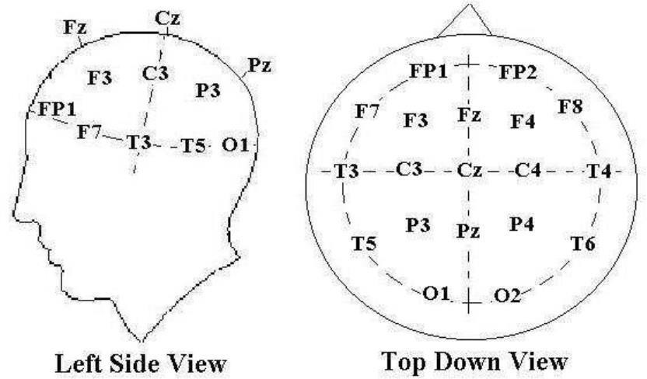
Fig. 1. Electrode Placement System

Code Setup:

  - Download and extract zip file from https://github.com/abhilasha2614/Biorobotics_lab_4
  - Download from ‘branch1new’ branch
  - An import python notebook in google colab also.
  - Install requirements.txt file.

UNICORN EEG CAP Setup:

Unicorn Hybrid Black is a wearable EEG headset that can measure EEG data from 8 Unicorn Hybrid EEG Electrodes, sampled with 24 Bit and 250 Hz per channel for many different BCI applications.
- Start the Unicorn Suite and check with the TA if the License key is setup.
- Get yourself familiar with the Unicorn Recorder in the Unicorn Suite using the link https://www.unicorn-bi.com/video-tutorials/ (You only have to go through the Unicorn Recorder video).
- Insert the Unicorn Bluetooth Dongle into the USE socket, turn on the EEG headset. Note the serial number at the back of the Unicorn Brain Interface / Device to connect to the proper device.
- Attach the Unicorn Brain Interface to the magnetic docking adapter on the rear side of the cap. Put the Unicorn Cap with the attached
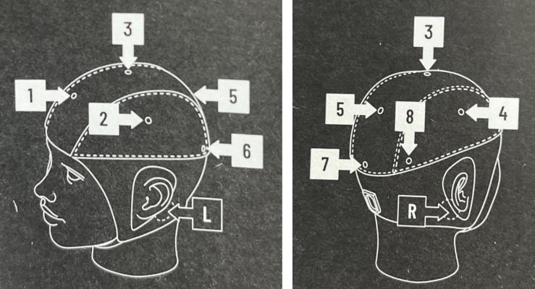
Fig. 2. Unicorn EEG Cap Electrode Markers

Data Streaming:
  - Open unicorn suite and install unicorn recorder to live stream EEG signals.
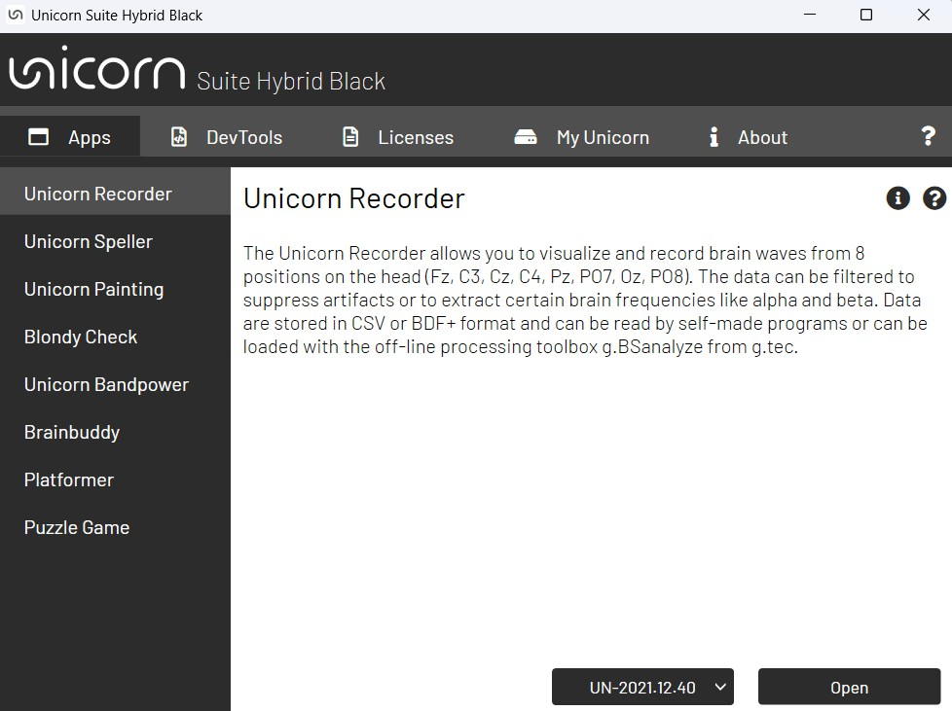

  - Click open to record the data
  - If the cap is successfully connected UN-2021.12.40 will appear.
  - Click connect and press play button you will see EEG signals.
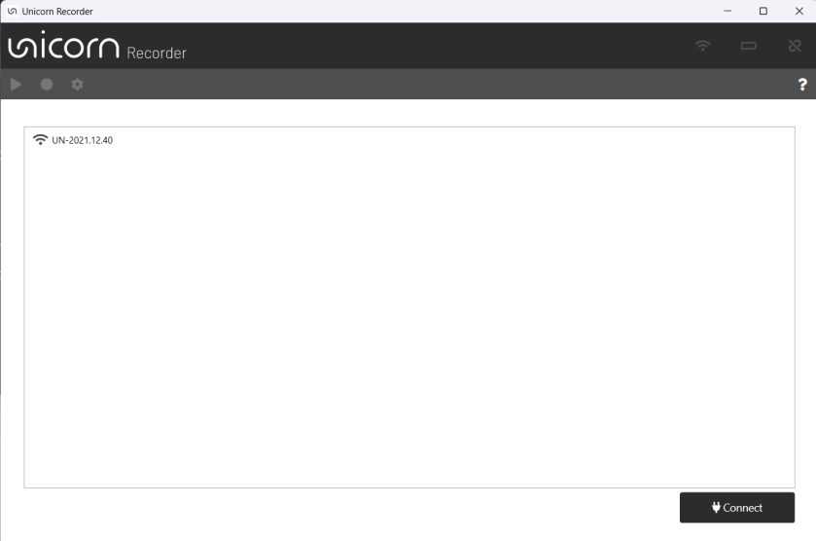

  - Select filter as 0.1-30Hz and notch filter 50 Hz.
  - The EEG signals will appear in the screen as below
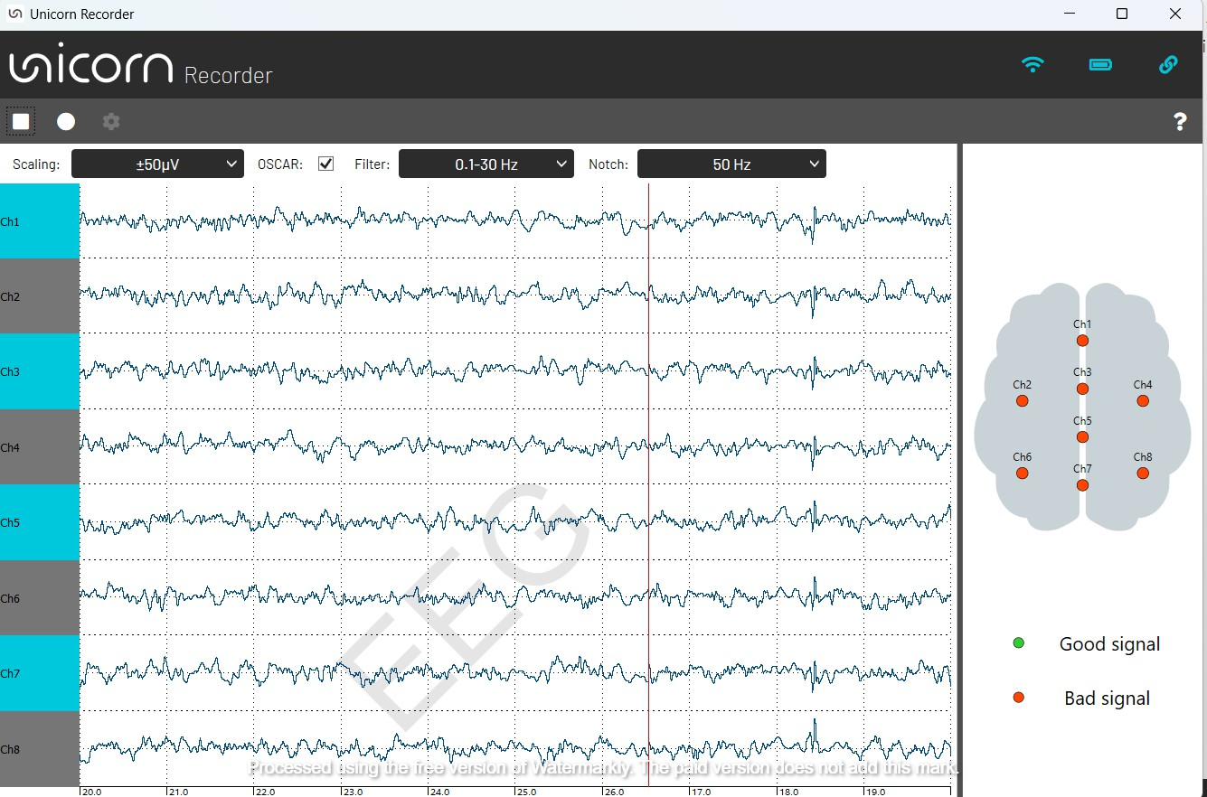

  - Finally save the signals as .csv files for further analysis.

Data Analysis:
- Download and extract zip file from https://github.com/abhilasha2614/Biorobotics_lab_4
- Please open the Lab4-EEG Analysis.ipynb jupyter notebook and follow the directions there.
- The data recorded should be put in the Data folder.
- Run each cell and note down the output.

Report Requirements:
  - Paste the outputs as screenshots
  - Picture of EEG band attached
  - Add discussion on need for EEG in real world applications

1.
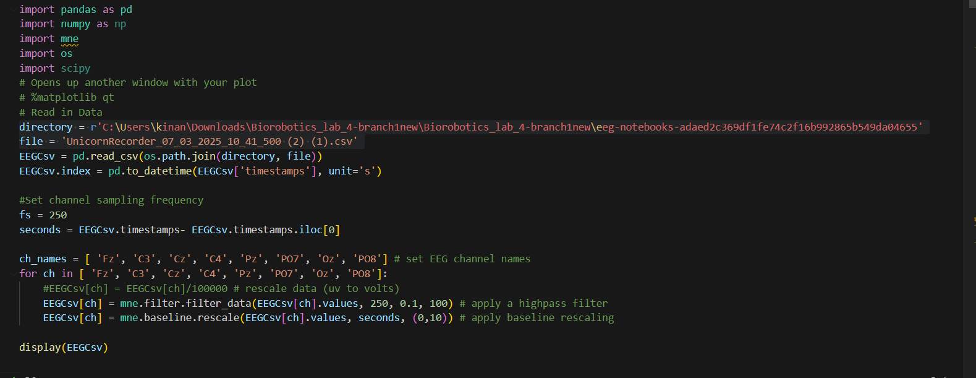

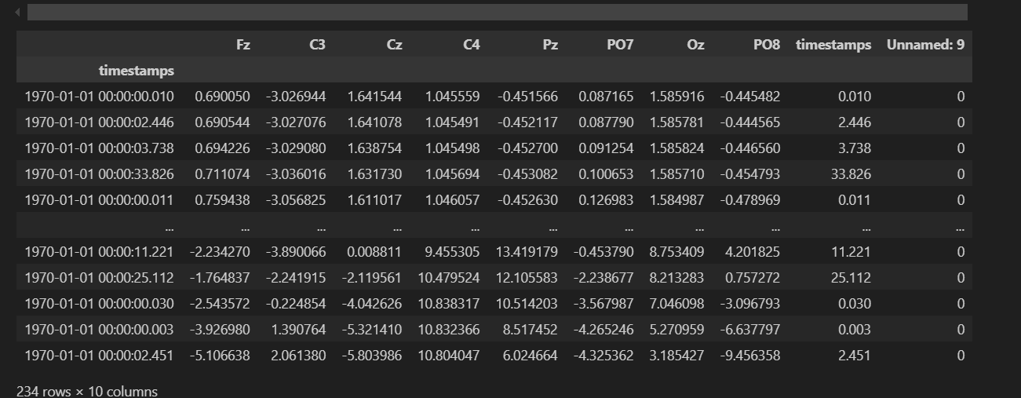

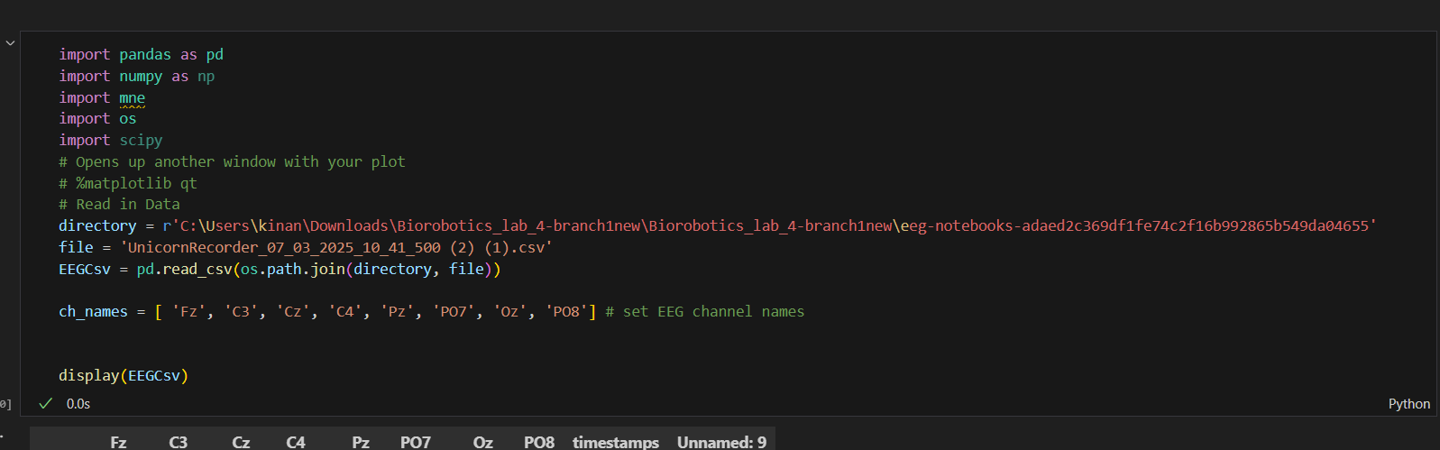
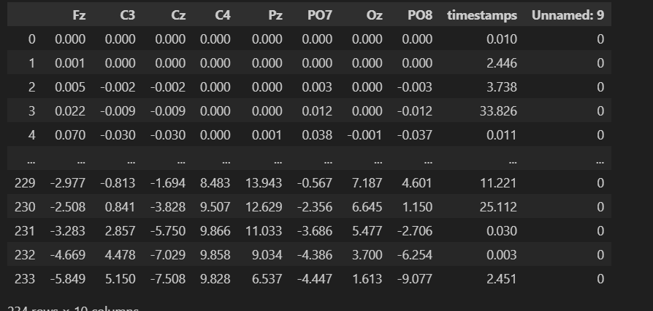

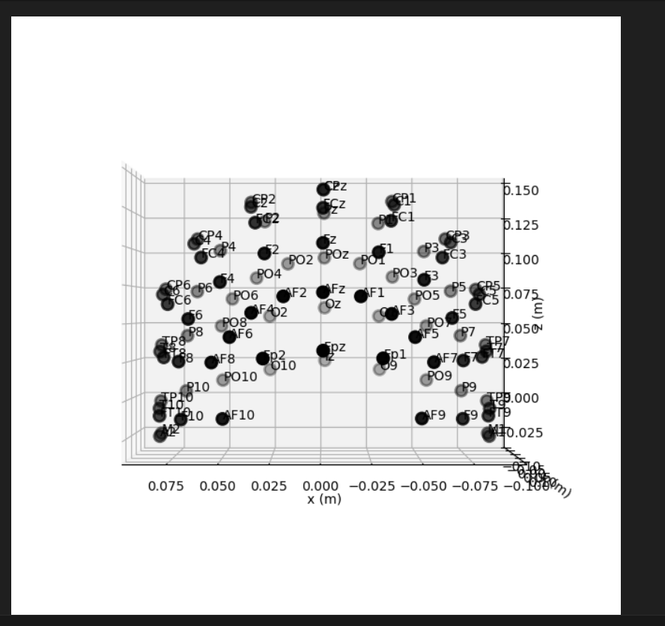
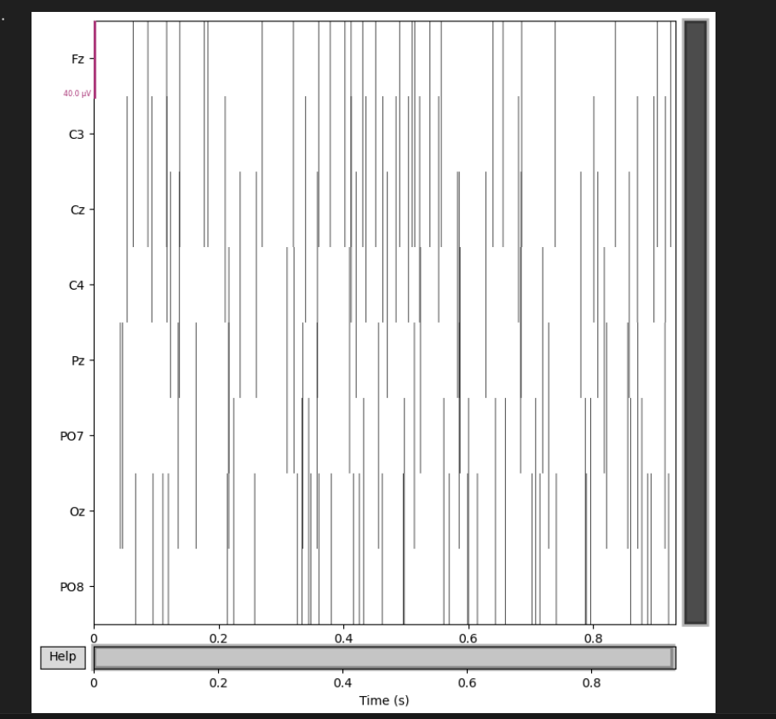
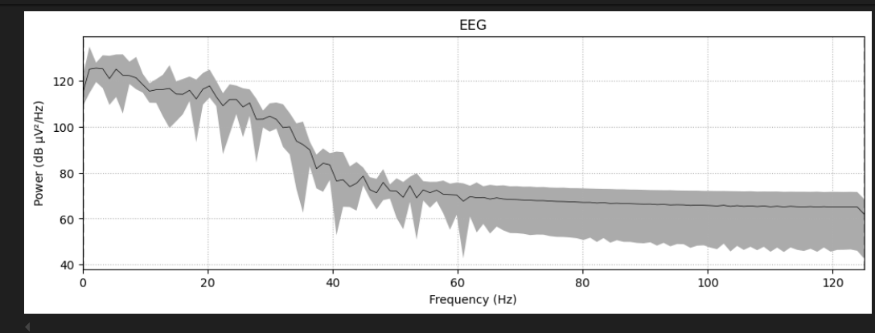
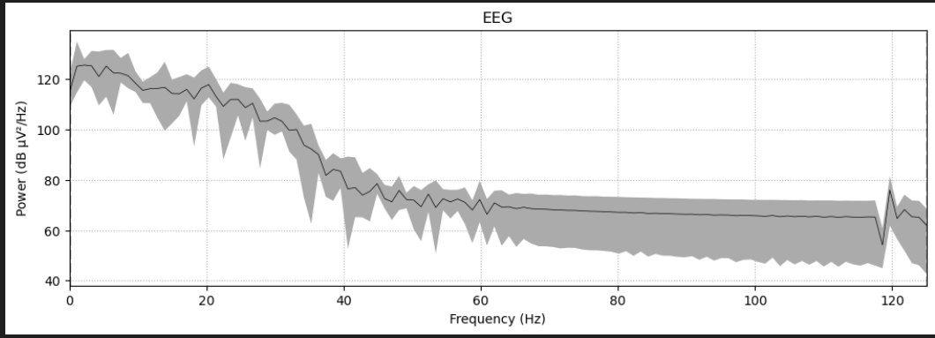
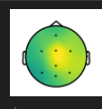
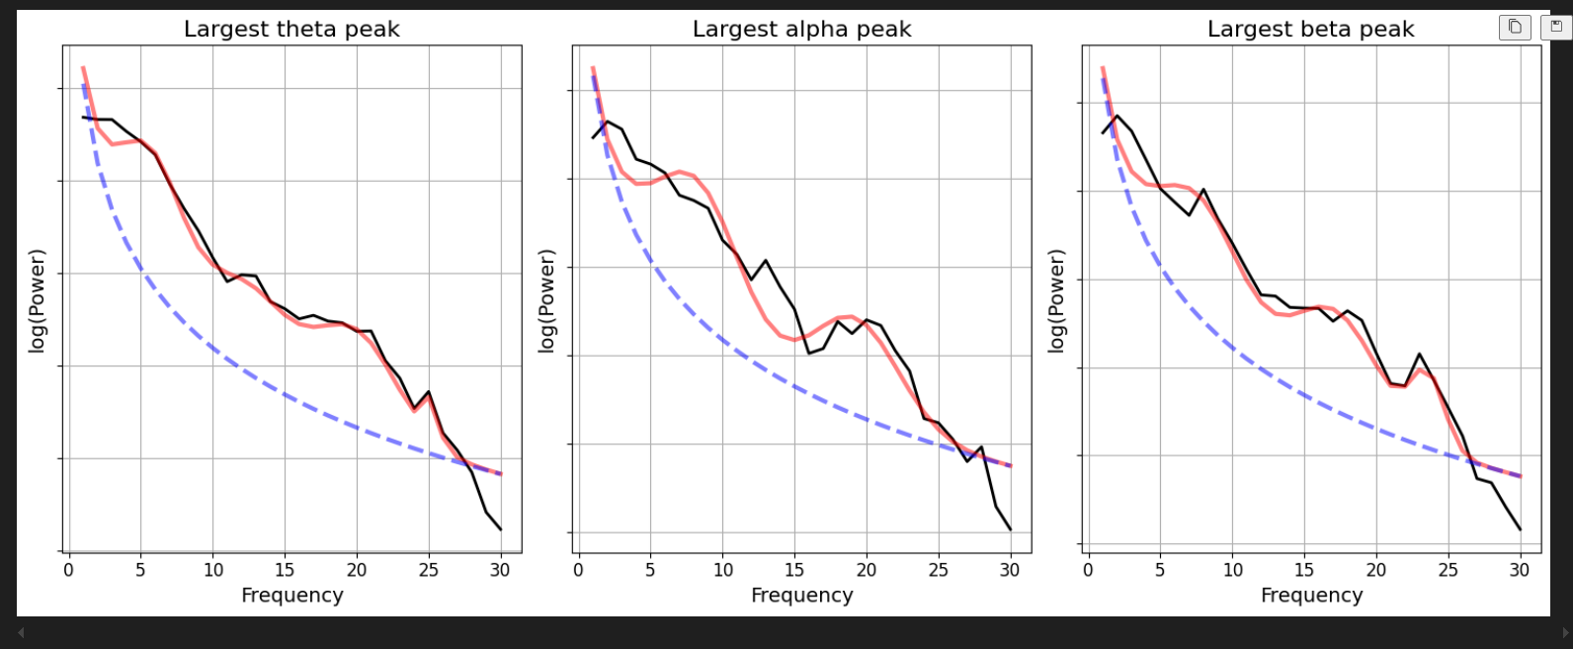
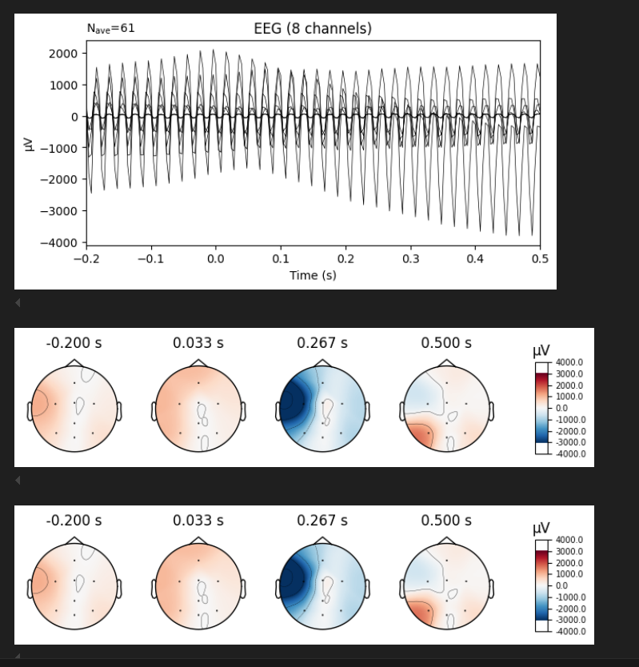
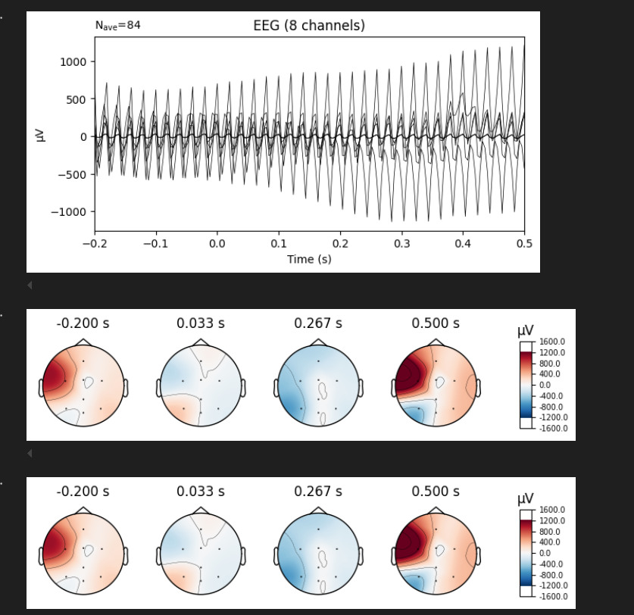

2.



3.

EEG is not only a piece of equipment in a lab experiment but a very important technology with massive real-world applications still expanding as the hardware and the analysis methods become increasingly advanced.

In practice, EEG is a cornerstone diagnostic examination. Its non-invasiveness and good temporal resolution allow clinicians to recognize very rapid electrical alterations in the brain. This is particularly important in epilepsy diagnosis, where the ability to capture transient seizure activity is essential. Beyond epilepsy, EEG is used in the assessment of sleep disorders by examining sleep stages and detecting abnormalities such as insomnia or sleep apnea. Its usefulness is also apparent in the monitoring of brain activity in patients with traumatic brain injury, providing real-time feedback regarding brain function in the recovery period and guiding treatment in intensive care.

EEG lies at the heart of the development of brain-computer interfaces (BCIs). BCIs translate the signals in the brain into the control of outside devices. It's a technology revolution for people with motor disability since it enables them to control prosthetic limbs, wheelchairs, or computer cursors with their brains. Advanced signal processing and learning algorithms are used in decoding intent-based movement-associated EEG patterns so that BCIs become more responsive and reliable. With emerging systems, they will be more accessible, further bridging the gap between neuroscience and everyday assistive technology.

EEG in research provides valuable information on the performance of the brain during cognition. Its temporal capacity permits researchers to investigate the sequence of the neural operations that go with perception, attention, memory, and decision-making. This information proves critical in making models of human cognition and the elucidation of the neural substrate for mental illness. Researchers can, for example, identify patterns linked with the anticipation of loading cognition or mental exhaustion with the hope for neuroergonomics advances. It can be used in the development of safer and more productive working environments, particularly for occupations with a great deal of stress or risk, such as flying or surgical operations.

In addition to this, the development of wearable EEG devices is eliminating the necessity of the laboratory or clinical environment. Consumer-level EEG headsets are being utilized in applications from mental wellness and meditation to personalized neurofeedback training. It is feasible for such headsets to monitor the brain's reaction when performing everyday tasks and give the user feedback on his mental state and allow customization by the individual of focus or relaxation techniques. With the development of wearable technology, EEG utilization will become ubiquitous in other smart devices for the monitoring of overall health and well-being, furthering the realm of personalized medicine.

Practical applications are enhanced by multimodal approaches too. With the integration of other imaging modalities, e.g., the fMRI or near-infrared spectroscopy (NIRS), the shortcomings of the EEG, e.g., the relatively low spatial resolution, are overcome. With multimodal integration, the greater visual information over the brain function is achieved, much more useful for clinical diagnoses as well as research into cognition.

Lastly, EEG's impact on the creation of neuroadaptive technologies cannot be overemphasized. With advancements in real-time processing and artificial intelligence, EEG signals are being used today to create adaptive systems that self-modulate in real time according to the cognition and the state of emotions of an individual. Such a system can be used in a vast variety of applications, including enhancing the useability in virtual reality as well as individualizing learning environments in the classroom. In total, EEG is an essential instrument in research and application alike. Its application, ranging from neurologicial disorder diagnosis to facilitating high-level brain-computer interfaces, indicates the potential for transforming how individuals perceive they understand the brain and how they interface with it in practical applications. Expanding endlessly with emerging technology and the means for data analysis guarantees that it will continue to open up applications, and EEG will remain a central piece in forthcoming adaptive and personalized technologies.

